**Practical 2: Study of Data Manipulation Language Statement**

**A) Insert the following records in above created table**

EMP TABLE

|  |  |  |  |  |  |  |  |
| --- | --- | --- | --- | --- | --- | --- | --- |
| EMPNO | ENAME | JOB | MGR | HIREDATE | SAL | COMM | DEPTNO |
| 7839 | KING | PRESIDENT |  | 17-Nov-81 | 5000 |  | 10 |
| 7698 | BLAKE | MANAGER | 7839 | 01-May-81 | 2850 |  | 30 |
| 7782 | CLARK | MANAGER | 7839 | 09-Jun-81 | 2450 |  | 10 |
| 7566 | JONES | MANAGER | 7839 | 02-Apr-81 | 2975 |  | 20 |
| 7788 | SCOTT | ANALYST | 7566 | 19-Apr-87 | 3000 |  | 20 |
| 7902 | FORD | ANALYST | 7566 | 03-Dec-81 | 3000 |  | 20 |
| 7369 | SMITH | CLERK | 7902 | 17-Dec-80 | 800 |  | 20 |
| 7499 | ALLEN | SALESMAN | 7698 | 20-Feb-81 | 1600 | 300 | 30 |
| 7521 | WARD | SALESMAN | 7698 | 22-Feb-81 | 1250 | 500 | 30 |
| 7654 | MARTIN | SALESMAN | 7698 | 28-Sep-81 | 1250 | 1400 | 30 |
| 7844 | TURNER | SALESMAN | 7698 | 08-Sep-81 | 1500 | 0 | 30 |
| 7876 | ADAMS | CLERK | 7788 | 23-May-87 | 1100 |  | 20 |
| 7900 | JAMES | CLERK | 7698 | 03-Dec-81 | 950 |  | 30 |
| 7934 | MILLER | CLERK | 7782 | 23-Jan-82 | 1300 |  | 10 |

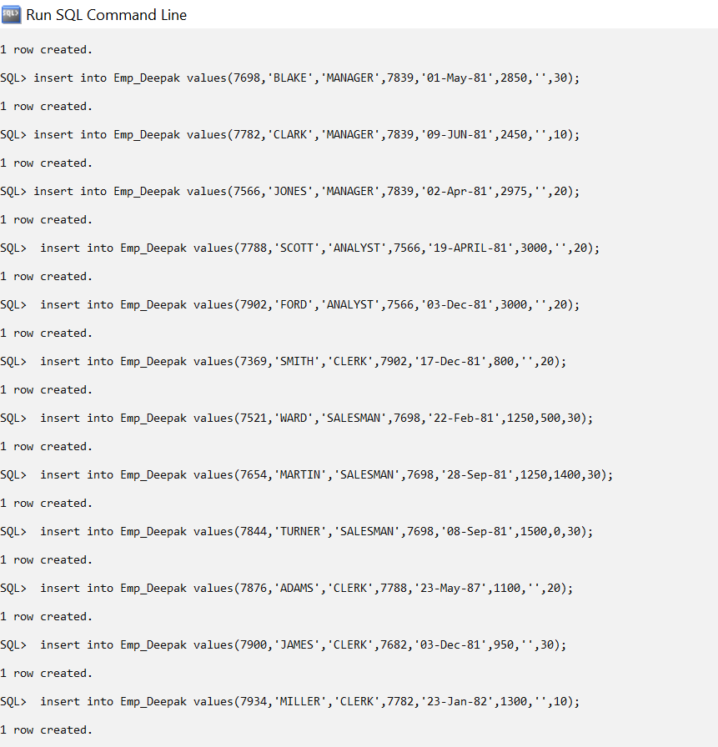

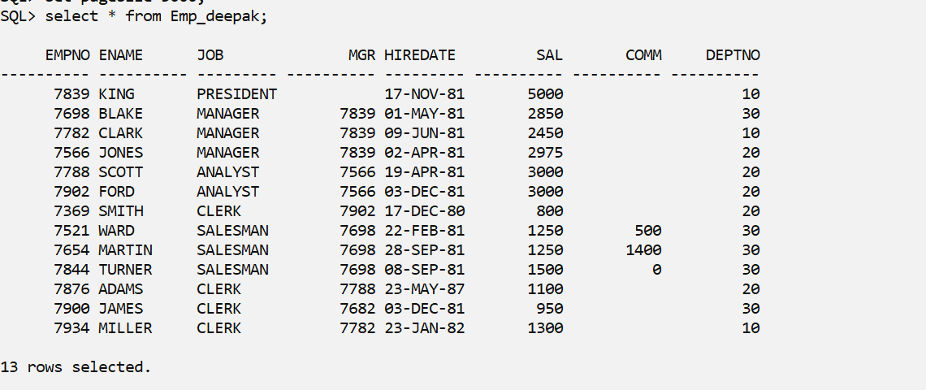

DEPT TABLE

|  |  |  |
| --- | --- | --- |
| DEPTNO | DNAME | LOC |
| 10 | ACCOUNTING | NEW YORK |
| 20 | RESEARCH | DALLAS |
| 30 | SALES | CHICAGO |
| 40 | OPERATIONS | BOSTON |

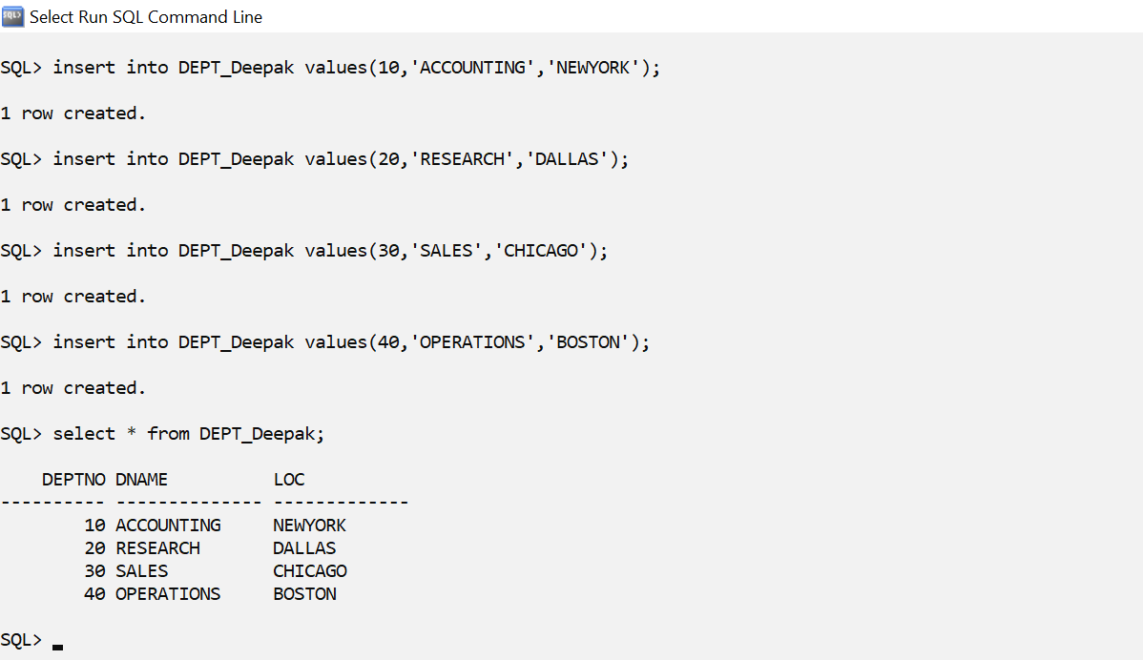

**B) Update and Delete Queries**

1) Update the salary of employees working as CLERK by 500.

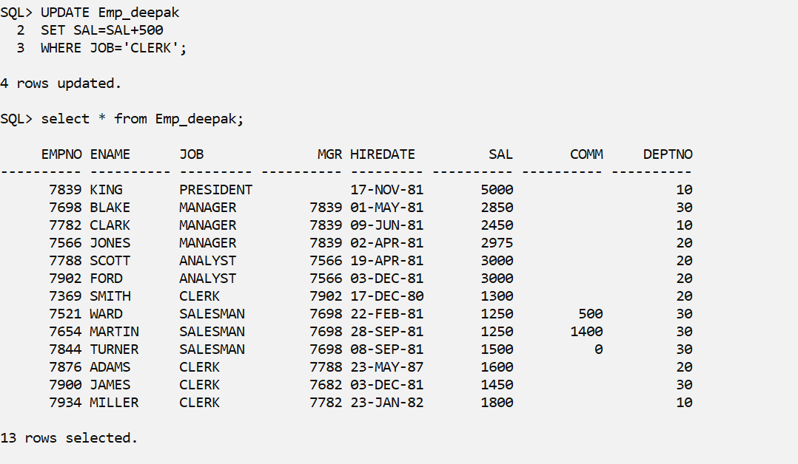

2)Update the manager of James as CLARK.

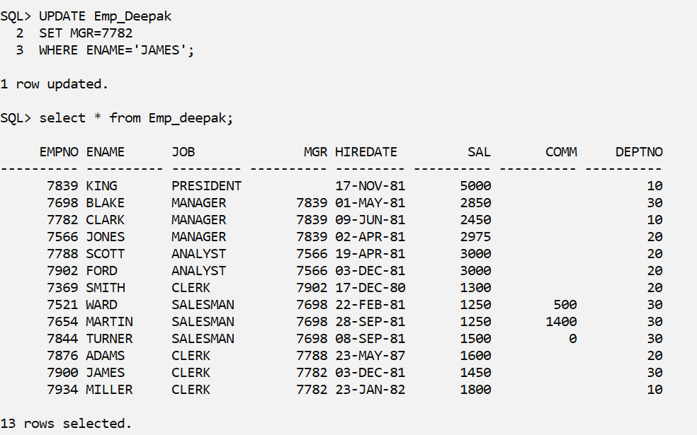

3)Change the role of Miller as MANAGER.

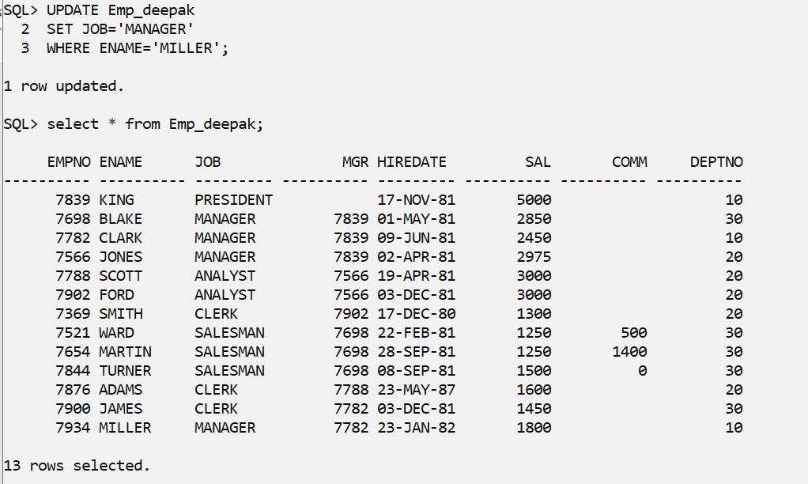

4)Delete the records of Manager

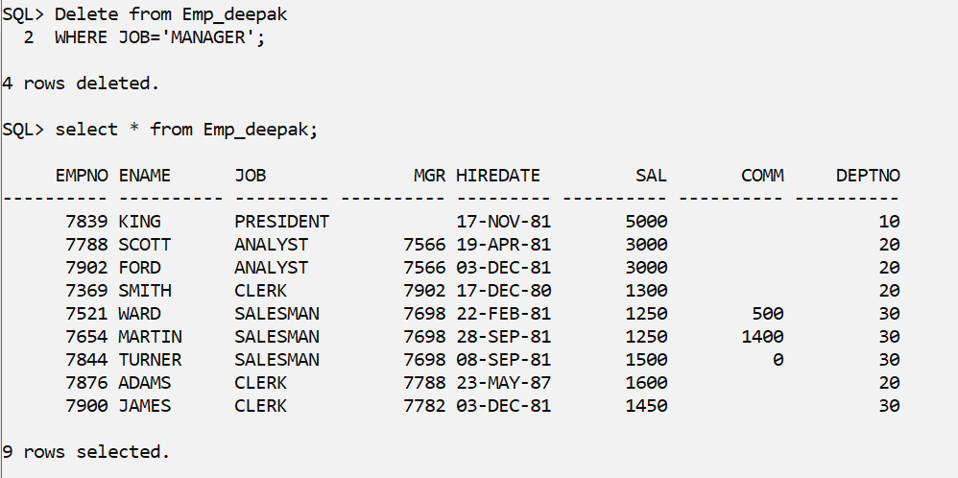

5)Delete the records when salary is greater than 1000.

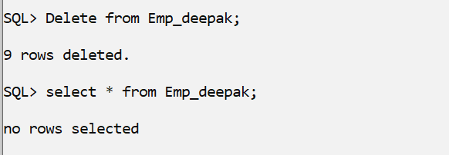

* create table Emp_Deepak(Empno int primary key,Ename varchar(10) not null,job varchar(9),mgr int,hiredate date,sal number(7,2),comm int,DEPTNO int,foreign key(DEPTNO) references DEPT_Deepak(DEPTNO));

